ASSIGNMENT – 10

Consider the following tables:
MATCH (match_id, team1, team2, ground, mdate, winner)
PLAYER (p_id, lname, fname, country, yborn, bplace, ftest)
BATTING (match_id, p_id, mts, order, out_type, fow, nruns, nballs, fours, sixes)
BOWLING (match_id, p_id, novers, maidens, nruns, nwickets)
- Draw the appropriate ER, EER and Relational model for the given data.

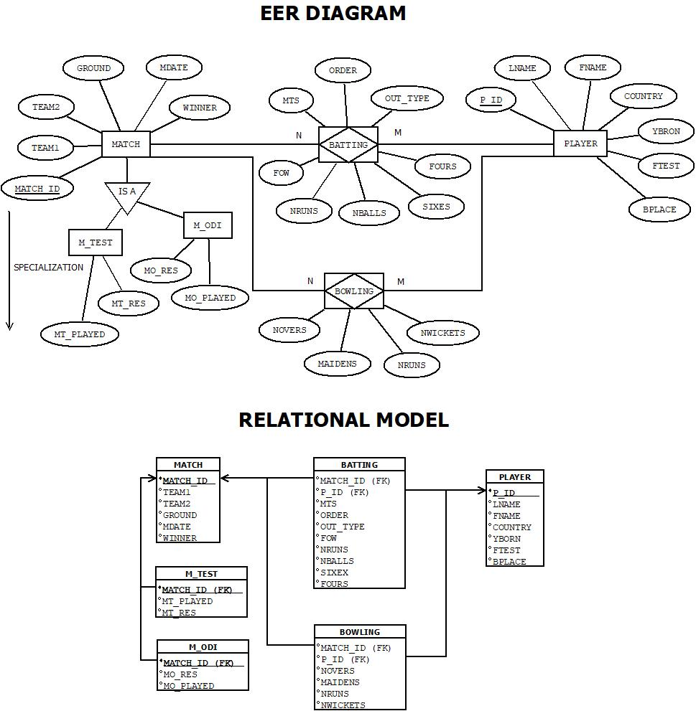
Assumptions: -
- Each match is uniquely identified by a match_id.
- Every match involves exactly two teams: team1 and team2.
- The match takes place at a specific ground on a specific mdate.
- The winner must be either team1, team2, or 'Draw'.
- Matches are specialized into two types: M_TEST (Test matches) and M_ODI (One Day Internationals).
- M_TEST includes mt_played (number of days played) and mt_res (detailed Test result).
- M_ODI includes mo_played (overs played) and mo_res (detailed ODI result).
- Every player is uniquely identified by p_id.
- Player details include fname, lname, country, yborn (year of birth), bplace (birthplace), and ftest (year of first Test).
- A player can play in multiple matches and may bat, bowl, or both in a match.
- The batting table records a player’s batting details per match including order, mts (minutes), out_type, fow, nruns, nballs, fours, and sixes.
- The bowling table records a player’s bowling stats per match including novers, maidens, nruns, and nwickets.
- match_id and p_id in batting and bowling act as foreign keys referencing the match and player tables respectively.
- Every performance entry in batting or bowling assumes the player participated in that match.
- No attribute in a primary key or required foreign key can be null.
- All statistical values such as runs, balls, overs, and wickets must be valid and within logical constraints (e.g., overs < 10 in ODI).
- A player cannot appear in a match unless they have either batting or bowling performance recorded.
- The winner column in the match table must not be null and must match one of the participating teams or be ‘Draw’.
- The model supports specialization for storing match-type-specific data in separate tables (M_TEST and M_ODI).
- Many-to-many relationships exist between player and match through batting and bowling.

- Write SQL expressions for the following:
Create Table and Insert Value: -
- MATCH
create table match (
match_id varchar2(10) check (match_id like 'M%') primary key,
team1 varchar2(20) not null,
team2 varchar2(20) not null,
ground varchar2(20) not null,
mdate date not null,
winner varchar2(20),
constraint winner_check check (winner = team1 or winner = team2 or winner = 'Draw')
);
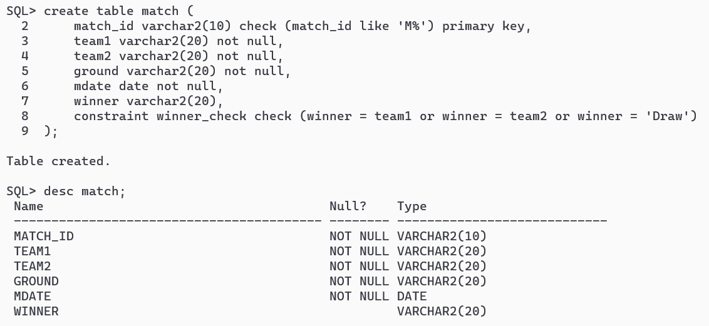
insert all
INTO match VALUES ('M001', 'India', 'Australia', 'Wankhede', TO_DATE ('2024-03-15', 'YYYY-MM-DD'), 'India')
INTO match VALUES ('M002', 'England', 'Pakistan', 'Lords', TO_DATE ('2024-04-10', 'YYYY-MM-DD'), 'Draw')
INTO match VALUES ('M003', 'England', 'New Zealand', 'Newlands', TO_DATE ('2024-02-25', 'YYYY-MM-DD'), 'New Zealand')
INTO match VALUES ('M004', 'Sri Lanka', 'Bangladesh', 'Sri Lanka', TO_DATE ('2024-05-05', 'YYYY-MM-DD'), 'Bangladesh')
INTO match VALUES ('M005', 'India', 'England', 'Eden Gardens', TO_DATE ('2024-06-12', 'YYYY-MM-DD'), 'England')
INTO match VALUES ('M006', 'India', 'Australia', 'Sydney', TO_DATE ('2024-03-18', 'YYYY-MM-DD'), 'India')
INTO match VALUES ('M007', 'India', 'Sri Lanka', 'Sri Lanka', TO_DATE ('2018-04-28', 'YYYY-MM-DD'), 'India')
select * from dual;
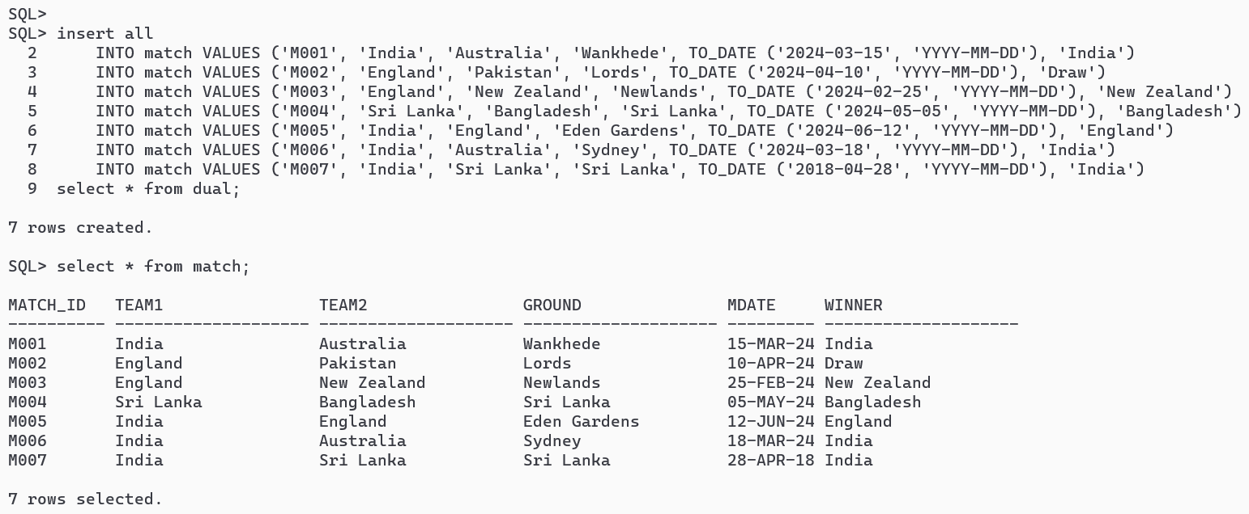

- PLAYER
create table player (
p_id varchar2(20) check (p_id like 'P%') primary key,
fname varchar2(20) not null,
lname varchar2(20) not null,
country varchar2(20) not null,
yborn number check (yborn < 2009) not null,
bplace varchar2(20) not null,
ftest number (2)
);
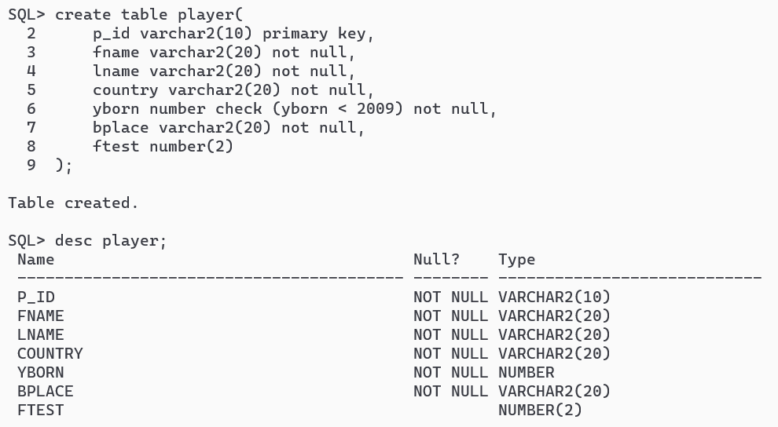
insert all
INTO player VALUES ('P001', 'Virat', 'Kohli', 'India', 1988, 'Delhi', 11)
INTO player VALUES ('27001', 'Steve', 'Smith', 'Australia', 1989, 'Sydney', 10)
INTO player VALUES ('P003', 'Joe', 'Root', 'England', 1990, 'Sheffield', 12)
INTO player VALUES ('P004', 'Kane', 'Williamson', 'New Zealand', 1990, 'Tauranga', 10)
INTO player VALUES ('P005', 'Babar', 'Azam', 'Pakistan', 1994, 'Lahore', 16)
INTO player VALUES ('P006', 'MS', 'Dhoni', 'India', 1987, 'Ranchi', 20)
INTO player VALUES ('P007', 'Sakib Ul', 'Hasan', 'Bangladesh', 1995, 'Dhaka', 19)
select * from dual;
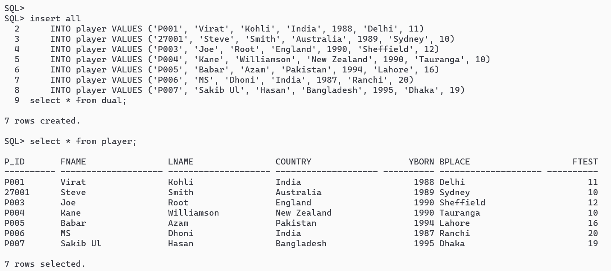

- BATTING
create table batting (
match_id varchar2(10) references match(match_id) on delete cascade,
p_id varchar2(10) references player (p_id) on delete cascade,
mts number(2) check (mts >= 0),
batting_order number(2) check (batting_order > 0 or batting_order < 12),
out_type varchar2(10) check (out_type in ('b', 'c', 'st', 'lbw', 'run out', 'not out')),
fow number(2) check (fow >= 0),
nruns number(4) check (nruns >= 0),
nballs number(3) check (nballs >= 0 and nballs < 300),
fours number(3) check (fours >= 0 and fours <= 251),
sixes number(3) check (sixes >= 0 and sixes <= 251)
);
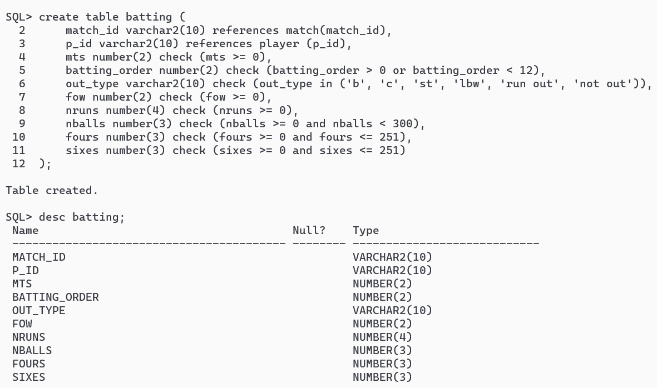

insert all
INTO batting VALUES ('M001', 'P001', 99, 3, 'b', 2, 75, 95, 8, 1)
INTO batting VALUES ('M001', '27001', 90, 4, 'c', 3, 105, 90, 6, 5)
INTO batting VALUES ('M003', 'P003', 96, 2, 'lbw', 1, 88, 102, 10, 0)
INTO batting VALUES ('M003', 'P004', 85, 5, 'not out', null, 25, 35, 1, 2)
INTO batting VALUES ('M004', 'P007', 81, 2, 'run out', 6, 98, 123, 3, 5)
INTO batting VALUES ('M005', 'P005', 77, 1, 'b', 1, 0, 1, 0, 0)
INTO batting VALUES ('M002', 'P005', 77, 1, 'b', 1, 0, 1, 0, 0)
INTO batting VALUES ('M006', '27001', 90, 1, 'c', 3, 62, 70, 6, 2)
INTO batting VALUES ('M001', 'P006', 93, 5, 'c', 5, 153, 100, 10, 9)
INTO batting VALUES ('M007', 'P006', 93, 5, 'c', 5, 53, 22, 5, 2)
INTO batting VALUES ('M007', 'P001', 99, 3, 'not out', null, 123, 110, 4, 9)
select * from dual;
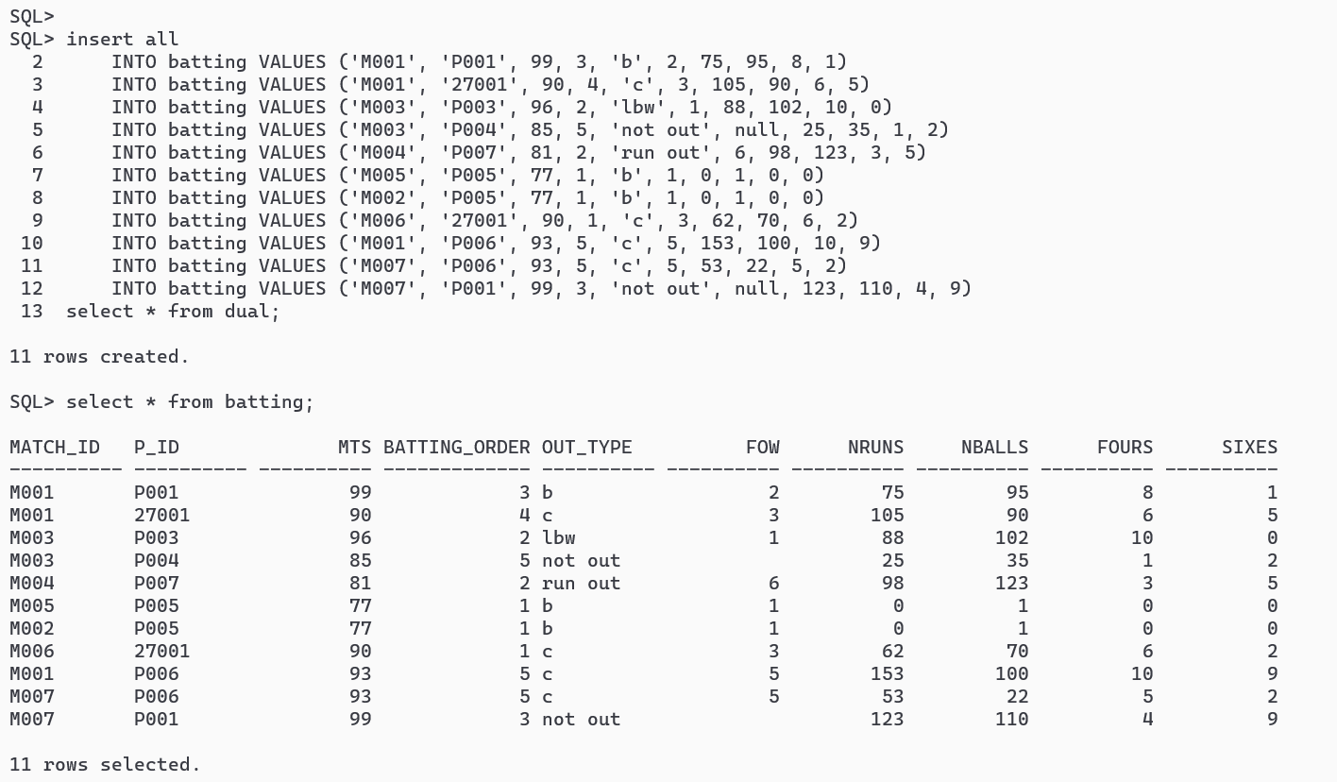

- BOWLING
create table bowling (
match_id varchar2 (10) references match(match_id) on delete cascade,
p_id varchar2 (10) references player (p_id) on delete cascade,
novers number (3, 1) check (novers >= 0 and novers < 10),
maidens number (2) check (maidens >= 0 and maidens < 10),
nruns number (3) check (nruns >= 0 and nruns <= 360),
nwickets number (2) check (nwickets >= 0 and nwickets <= 10)
);
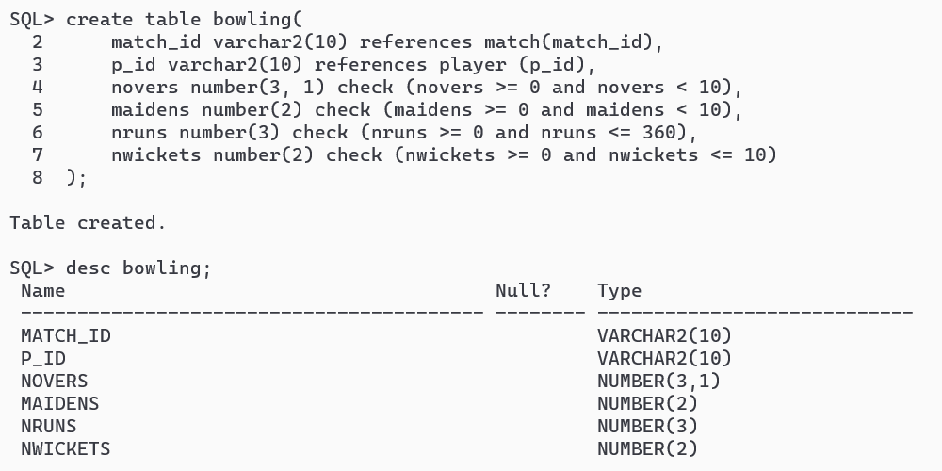
insert all
INTO bowling VALUES ('M001', 'P001', 8.4, 2, 45, 3)
INTO bowling VALUES ('M002', '27001', 9.0, 1, 50, 2)
INTO bowling VALUES ('M003', 'P003', 6.5, 0, 39, 1)
INTO bowling VALUES ('M004', 'P004', 7.2, 1, 60, 4)
INTO bowling VALUES ('M005', 'P005', 5.0, 0, 35, 0)
select * from dual;
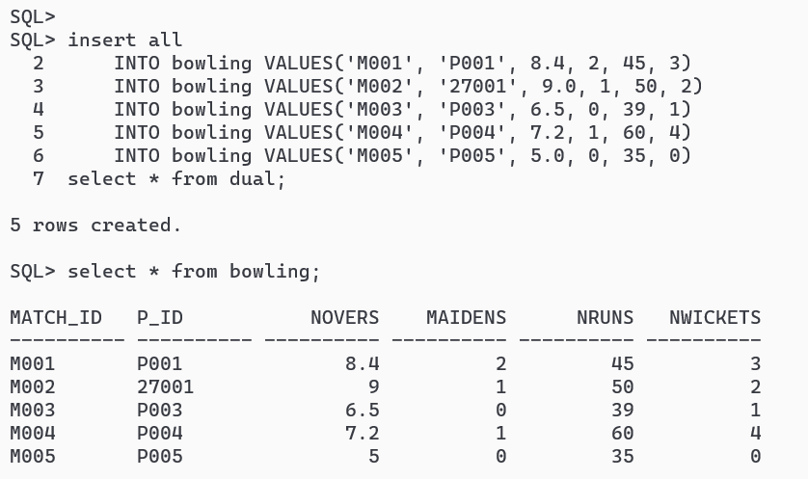

- M_TEST
create table m_test(
match_id varchar2(10) references match(match_id) on delete cascade,
primary key(match_id),
mt_played number(5,1),
mt_res varchar2(30)
);

insert all
into m_test values ('M002', 190, 'Draw')
select * from dual;
select * from m_test;
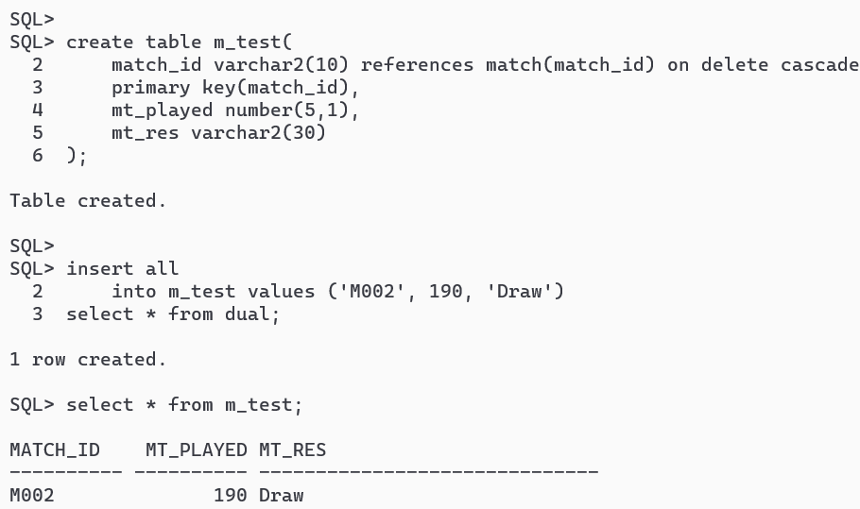
- M_ODI
create table m_odi(
match_id varchar2(10) references match(match_id) on delete cascade,
primary key(match_id),
mo_played number(5,1),
mto_res varchar2(30)
);
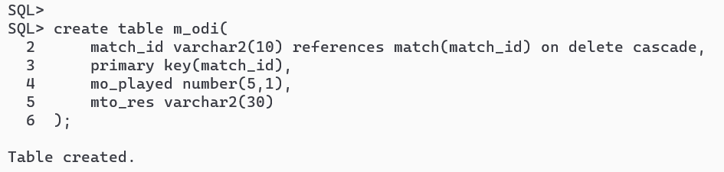
insert all
into m_odi values ('M001', 100, 'India won by 20 runs')
into m_odi values ('M003', 90.4, 'New Zealand won by 5 runs')
into m_odi values ('M004', 95.3, 'Bangladesh won by 3 wickets')
into m_odi values ('M005', 100, 'England won by 1 wickets')
into m_odi values ('M006', 80.5, 'India won by 150 runs')
into m_odi values ('M007', 99.2, 'India won by 10 runs')
select * from dual;
select * from m_odi;
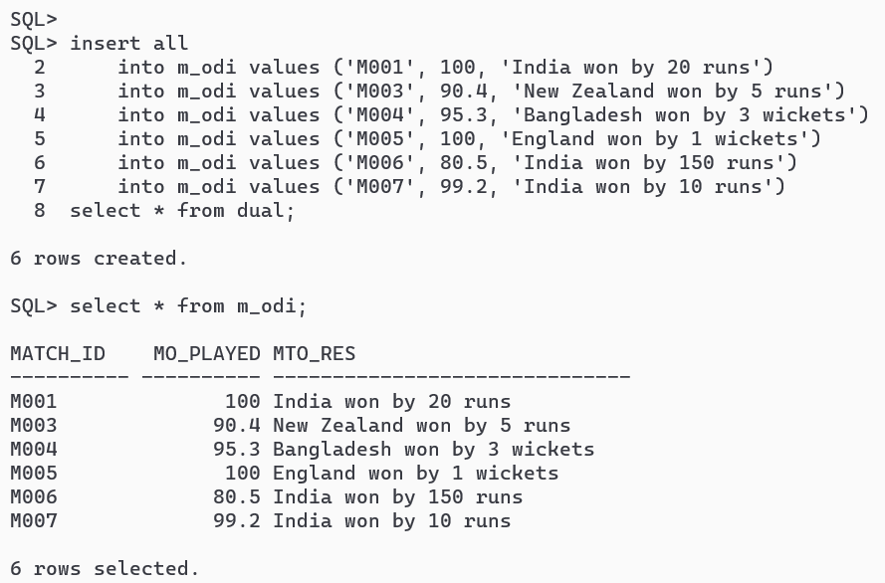

SQL QUERIES: -
- Find match ids of those matches in which player 27001 bats and makes more runs than he made at every match he played at Sydney.
- select match_id from batting where nruns > (
select max(nruns) from (
select * from batting where match_id in (
select match_id from match where ground='Sydney'
)
and p_id = '27001'
)
)

and p_id = '27001';
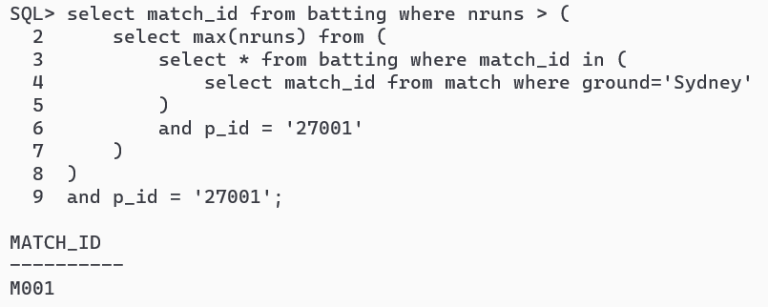
- Find player ids of players who have scored more than 30 in every ODI match that they have batted.

- select distinct p_id from batting where p_id not in (
select p_id from batting where nruns <= 30 and match_id in (
select match_id from m_odi
)
);
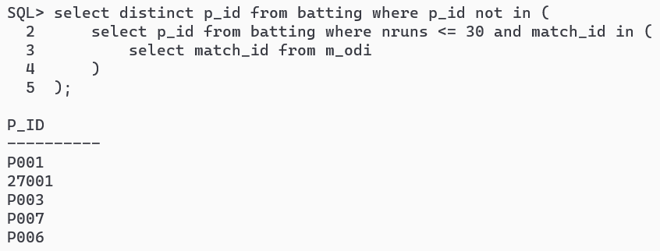

- Find the ids of players that had a higher average score than the average score for all players when they played in Sri Lanka.

- select p_id from (
select p_id, avg(nruns) as avg_runs from batting group by p_id
) where avg_runs > (
select avg(nruns) from batting where match_id in (
select match_id from match where ground = 'Sri Lanka'
)
);
